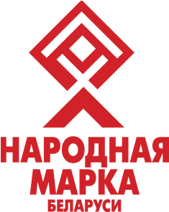
Production Unitary Enterprise
«Orsha Meat Canning Plant»
__________________________________________________________
The Republic of Belarus
211384, Orsha, Shklovskaya str., 34

Commercial offer

UE «Orsha Meat Canning Plant» invite for cooperation retail and wholesale companies, chain stores, operating in the market of meat products.
We offer a wide range of meat products: canned meat, canned porridges (kasha’s), baby food, also other made-up meat products and sausages, beef (chilled and frozen meat).
HS codes (EEU):
1. Canned meat (beef) – 1602 50 950 9;
2. Meat and cereal canes (rice) – 1904 90 100 0;
Meat and cereal canes (another) – 1904 90 800 0;
3. Baby food (meat, meat and cereal) – 1602 10 001 0;
4. Baby food (meat and vegetables) – 2104 20 001 0.
Our products are high-quality and ecologically clean. All of them conform to requirement of international standards. The high level of production organization is confirmed by the STB ISO 9001-2009 certificate, also STB HACCP certificate in the part of baby food production.
Our company offers flexible conditions for cooperation with individual approach to each partner. The system of discounts depending on volumes of the acquired products is applied. Payment conditions – 100% prepayment.
Lead time – 15 to 30 days. Delivery conditions – FCA Orsha. Custom clearance is made by the company.
Wide range of products makes possible to satisfy requirements of various categories of costumers. Products can be shipped automobile and by rail.
UE «Orsha Meat Canning Plant» is interested in establishing long-terms communications and will be glad if products of our company help you with your business.
Full information about our products you can find in price lists (ref. attachment) and also on our websites: www.omkk.by, www.babyhit.by.
Thank you very much, and we hope to receive your favorably response soon.

Best regards,
Department for External Economic Relations:
Aliaksandr Hancharenka
Maryna Luchko
Aliaksandr Zhdanau
Tatsiana Shpakouskaya
Tel. +375 (216) 53 07 03
Tel./fax +375 (216) 53 14 60
e-mail: ved@omkk.by, omkk@tut.by

